Tutorial -3

Advance Linux Command

1. **cat-** Can be used to create, write and view data into files.

**Syntax:** cat file_name

Description: The 'cat' command is the most universal and powerful tool. It is considered to be one of the most frequently used commands. It can be used to display the content of a file, copy content from one file to another, concatenate the contents of multiple files, display the line number, display $ at the end of the line, etc.

**Use of Command:**

* -b Omits line numbers from blank lines, when specified with the -n flag.
* -e Displays a $ (dollar sign) at the end of each line, when specified with the -v flag.
* -n Displays output lines preceded by line numbers, numbered sequentially from 1.
* -q does not display a message if the cat command cannot find an input file.
* -r replaces multiple consecutive empty lines with one empty line.

**Example:**

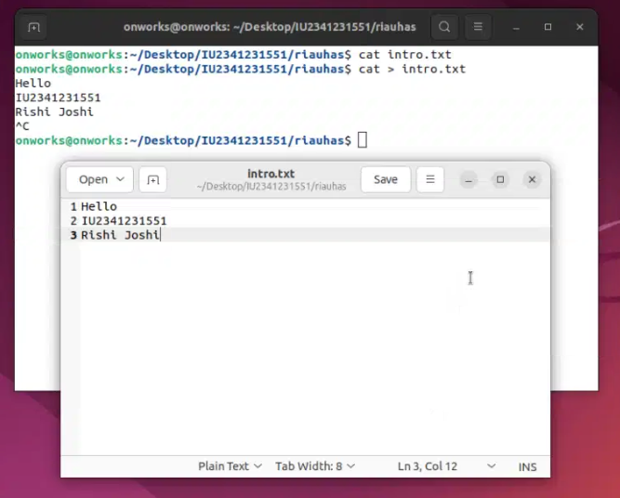

1. man - The "man" command in Linux is used to display the manual page for a given command, providing detailed information and usage instructions.

**Syntax:**

man [options] [command]

**Description:** The "man" command in Linux is a manual page viewer that displays detailed documentation for various commands. It helps users access comprehensive information, including usage, options, and examples, by simply specifying the desired command as an argument.

**Use of Command:**

* -k or --apropos: Searches for commands containing a specified keyword in their manual pages.
* -l or --local-file: Displays the manual page for a specific file instead of a command.
* -h or --help: Displays a summary of available options for the "man" command.

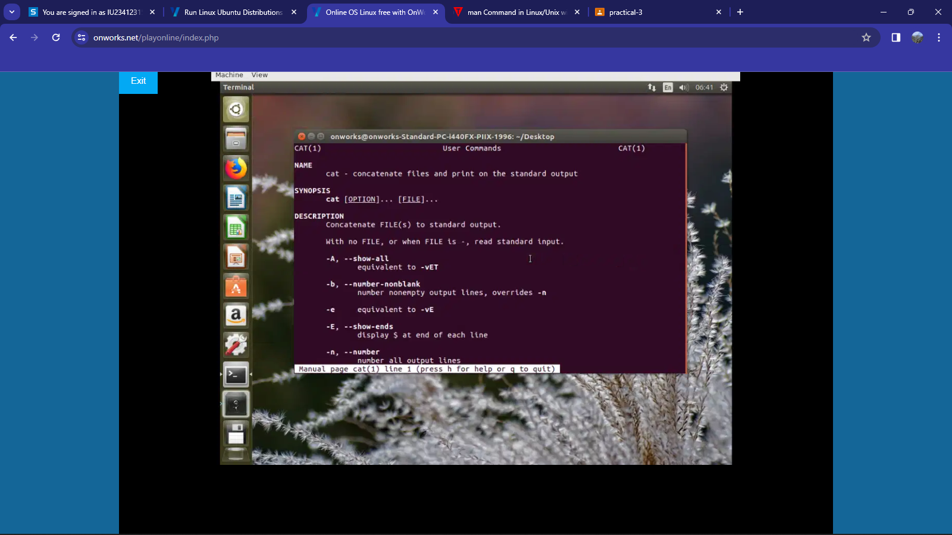**Example:**

1. **echo -**  The "echo" command in Linux is used to display text or variables to the terminal, making it a simple and versatile tool for outputting information.

**Syntax:**

echo [options] [text or variables]

**Description:**

The "echo" command in Linux is employed to display text or the values of variables on the terminal. It is a straightforward and commonly used command for generating output within scripts or the command line.

**Use of Command:**

* **-**n or --no-newline: Suppresses the trailing newline character, allowing multiple echoed items to appear on the same line.
* -e or --escape: Enables the interpretation of escape characters, allowing formatting within the echoed text.
* -E or --no-escape: Disables the interpretation of escape characters, treating backslashes as literal characters.
* -E or --no-escape: Disables the interpretation of escape characters, treating backslashes as literal characters.
* -s or --suppress-newline: Suppresses the trailing newline character, useful when you want to concatenate multiple echoed items without spaces.

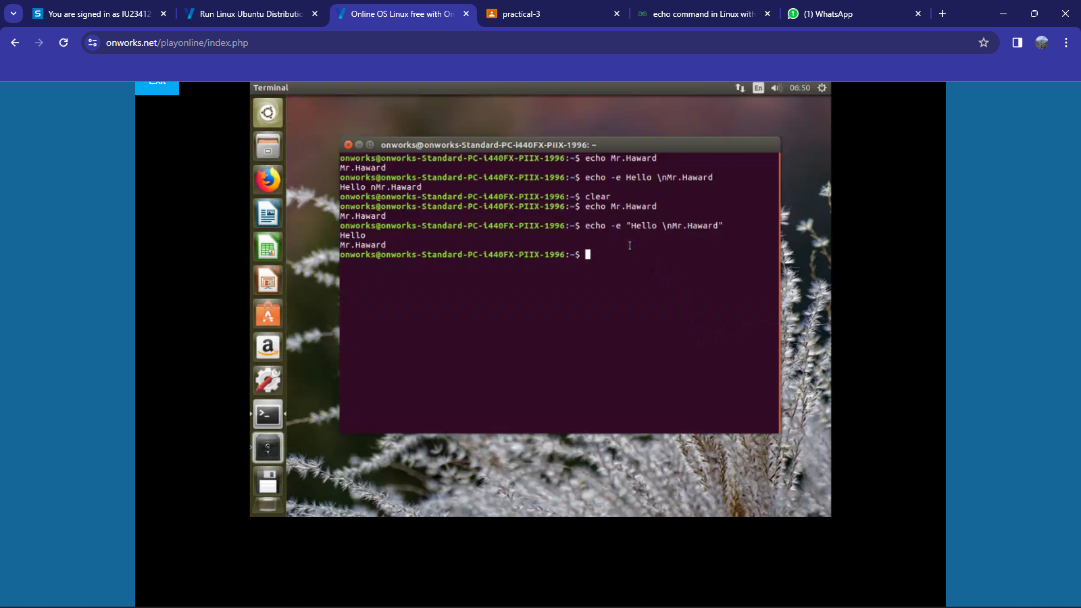 **Example:**

1. **bc** - The "bc" command in Linux is a calculator tool that allows users to perform arithmetic calculations within the command line environment.

**Syntax:**

bc [options] [file]

**Description:**

The "bc" command in Linux is a versatile command-line calculator that supports arbitrary-precision arithmetic. It enables users to perform mathematical calculations involving integers, floating-point numbers, and various mathematical functions. Additionally, "bc" can read input from files or interactively from the standard input, making it a powerful tool for complex calculations within the command-line environment.

Use of Command:

* -l, Loads the math library for access to additional mathematical functions.
* -s, Specifies the number of significant digits for the result.
* -q, Suppresses the welcome message and prompts, suitable for non-interactive scripts.
* -w, Warns about non-POSIX extensions, helping ensure portability of scripts.

**Example:**

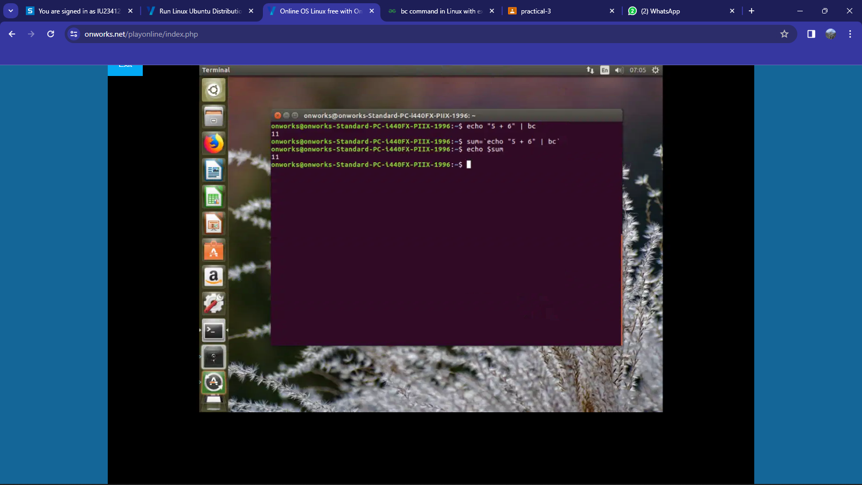

1. **tty** - The "tty" command in Linux displays the file name of the terminal connected to the standard input, revealing information about the current terminal device in use.

**Syntax**:

tty [OPTION]

**Description:**

The "tty" command in Linux is utilized to show information about the terminal device associated with the current session. When executed without options, it outputs the file name of the terminal connected to the standard input, providing insight into the terminal used in the command line environment.

Use of Command:

* -s, exits with a status of 0 if the standard input is a terminal.
* -L, Prints the terminal device name without any leading directories.
* -a, Prints all terminal names associated with the current session.

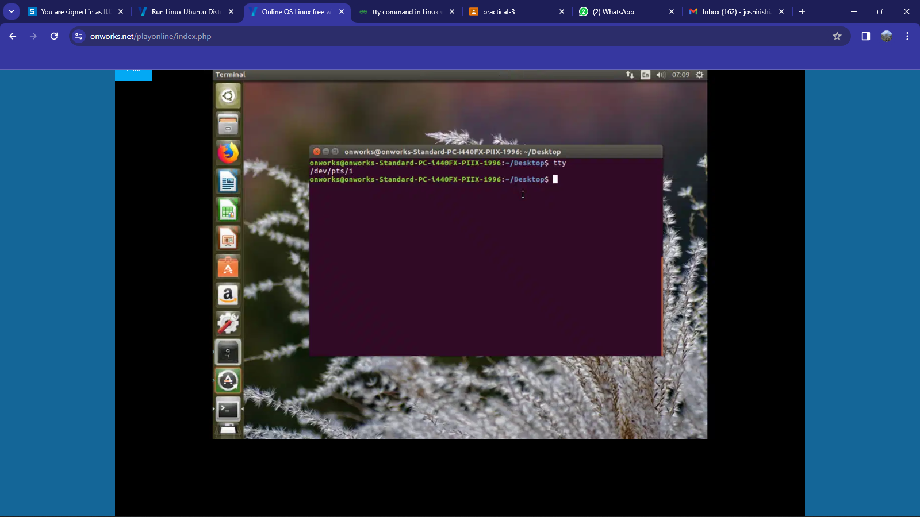Example:

1. **uname** - uname returns user name.

**Syntax**: uname

**Description:**

The uname command writes to standard output the name of the operating system that you are using. The machine ID number contains 12 characters in the following digit format: xxyyyyyymmss. The xx positions indicate the system and is always 00. The yyyyyy positions contain the unique ID number for the entire system.

Use of Command:

* -a --all Prints all system information.
* -s --kernel-name Prints the Kernel name.
* -n --nodename Prints the network node hostname.
* -r --kernel-release Prints the Kernel release number.
* -v --kernel-version Prints the Kernel version.
* -m --machine Outputs the machine's architecture type.
* -p --processor Prints the CPU type.
* -i --hardware-platform Prints hardware platform type.
* -o --operating-system Prints the operating system name.

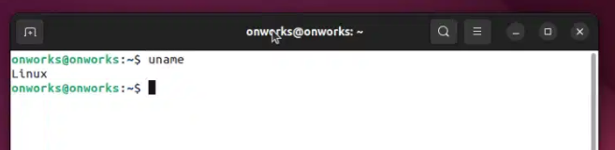Example:

1. **stty** - The "stty" command in Linux is employed to configure and display terminal settings, enabling control over aspects like character echoing and signal handling.

**Syntax**:

stty [OPTION]...

**Description:**

The "stty" command in Linux is used to display or modify terminal settings. It allows users to control various aspects of terminal behavior, including input and output processing, control characters, and line discipline settings. The command can be used to configure features such as echo behavior, erase and kill characters, control signals, and more, providing flexibility in adapting the terminal to specific user preferences or application requirements.

Use of Command:

* -a or --all: Displays all current terminal settings.
* -echo or -icanon: Disables character echoing or canonical mode, useful for capturing unprocessed input.
* intr or erase: Modifies interrupt or erase characters in terminal settings.
* -g or --save: Saves the current terminal settings for later restoration.

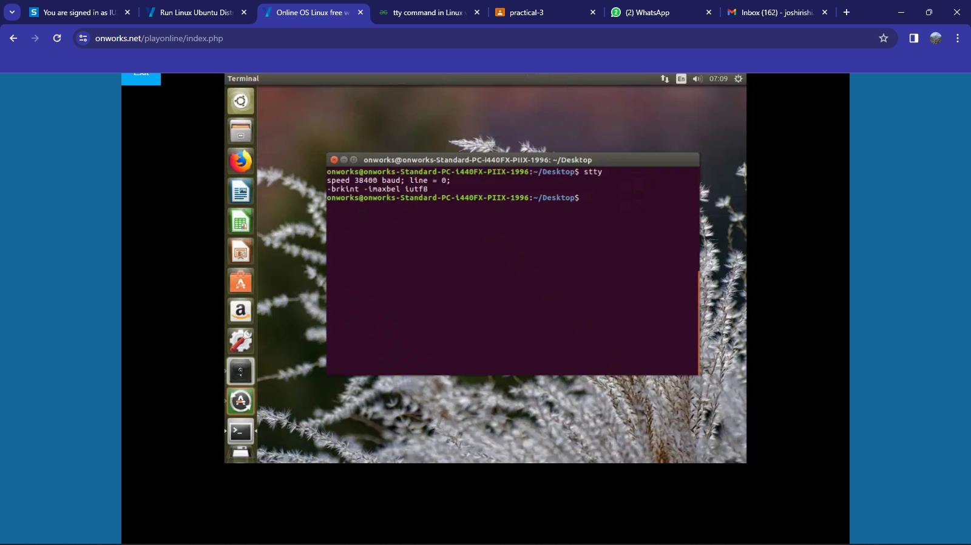Example:

1. mv - The "mv" command in Linux is used to move or rename files and directories, facilitating the organization and manipulation of file system elements.

**Syntax**:

mv [OPTION]... SOURCE... DESTINATION

**Description:**

The "mv" command in Linux is employed to move or rename files and directories within the file system. It allows users to relocate files or change their names, facilitating efficient organization and management of file resources. The command can also be used to move files between directories or across different file systems.

Use of Command:

·        -b or --backup: Creates backups of existing destination files during the move operation.

·        -i or --interactive: Prompts for confirmation before overwriting an existing destination file.

* -u or --update: Moves only when the source file is newer than the destination file or when the destination file is missing.
* -v or --verbose: Displays detailed information about the move operation.

|  |
| --- |
|  |
|  |  |

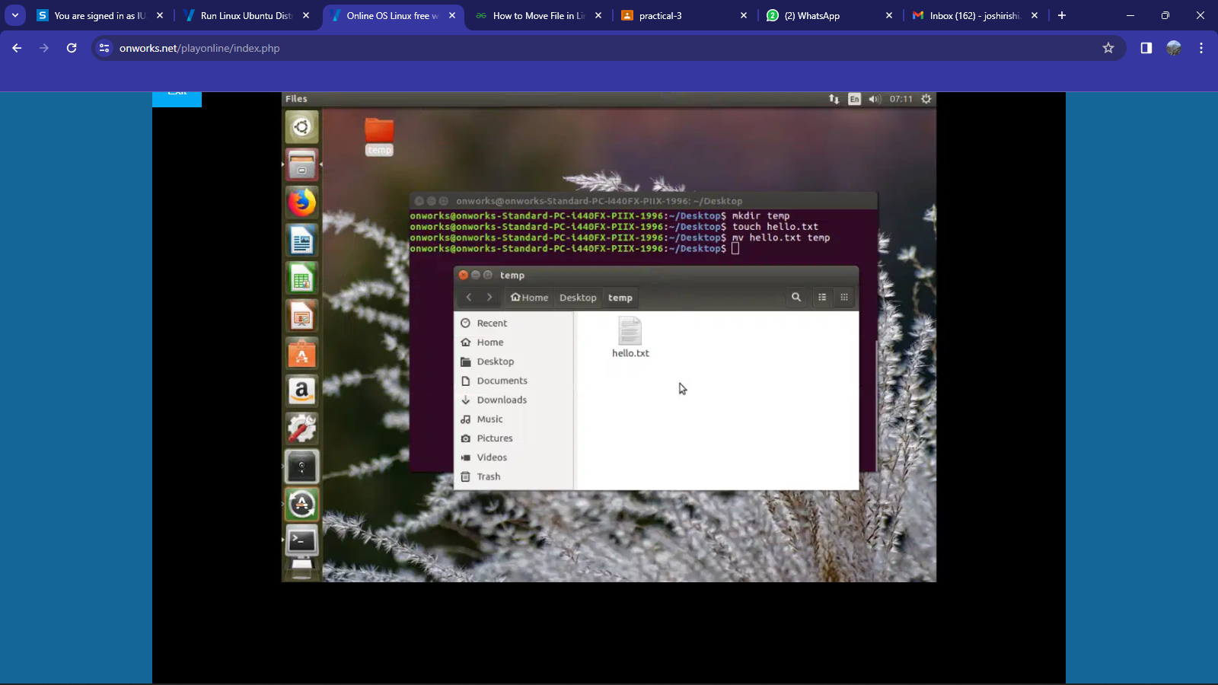Example:

1. nl - The "nl" command in Linux is used to add line numbers to a file or standard input, aiding in the enumeration of lines for reference or documentation purposes.

**Syntax**:

    nl [OPTION]... [FILE]...

**Description:**

The "nl" command in Linux is designed to add line numbers to the contents of a file or standard input. It assists in sequentially numbering lines, making it easier to reference and navigate through the content. Additionally, "nl" provides various options for customization, allowing users to control the formatting and appearance of the line numbers.

Use of Command:

·        -b or --body-numbering: Specifies the numbering style for body lines.

* -i or --line-increment: Sets the line number increment.
* -v or --starting-line-number: Specifies the starting line number.
* -w or --number-width: Sets the width of line numbers.

|  |
| --- |
|  |
|  |  |

Example:

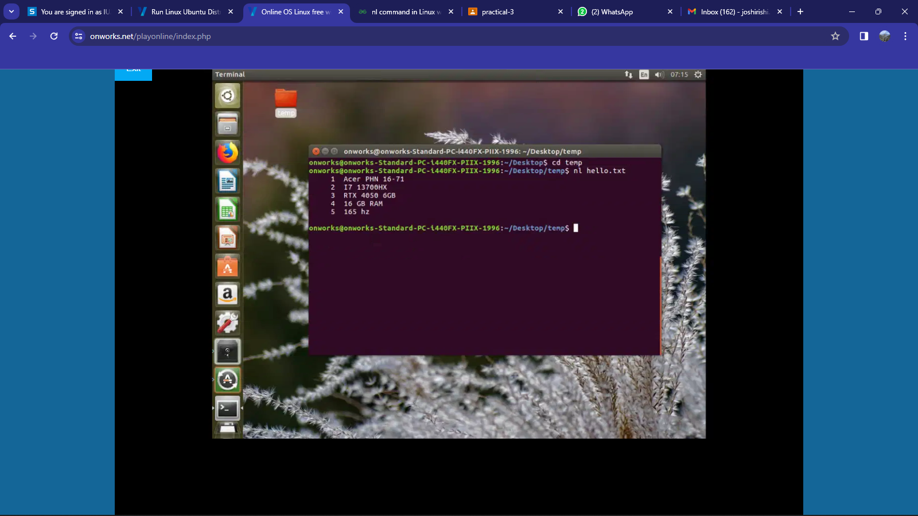

1. **cut** - The "cut" command in Linux is used to extract specific columns or fields from text files or input streams, providing a versatile way to manipulate and process delimited data.

**Syntax**:

     cut OPTION... [FILE]...

**Description:**

The "cut" command in Linux is a text-processing utility that enables the extraction of specific columns or fields from a file or input stream. It proves useful in handling delimited data, where columns are separated by a specified delimiter character. "cut" provides flexibility in selecting and outputting portions of the input text based on character position or byte range, making it a versatile tool for data manipulation and extraction.

Use of Command:

·        -f or --fields: Specifies the columns or fields to extract.

* -d or --delimiter: Sets the delimiter character for field separation.
* -c or --characters: Defines the character positions or range to extract.
* -s or --only-delimited: Omits lines without delimiters from the output.

|  |
| --- |
|  |
|  |  |

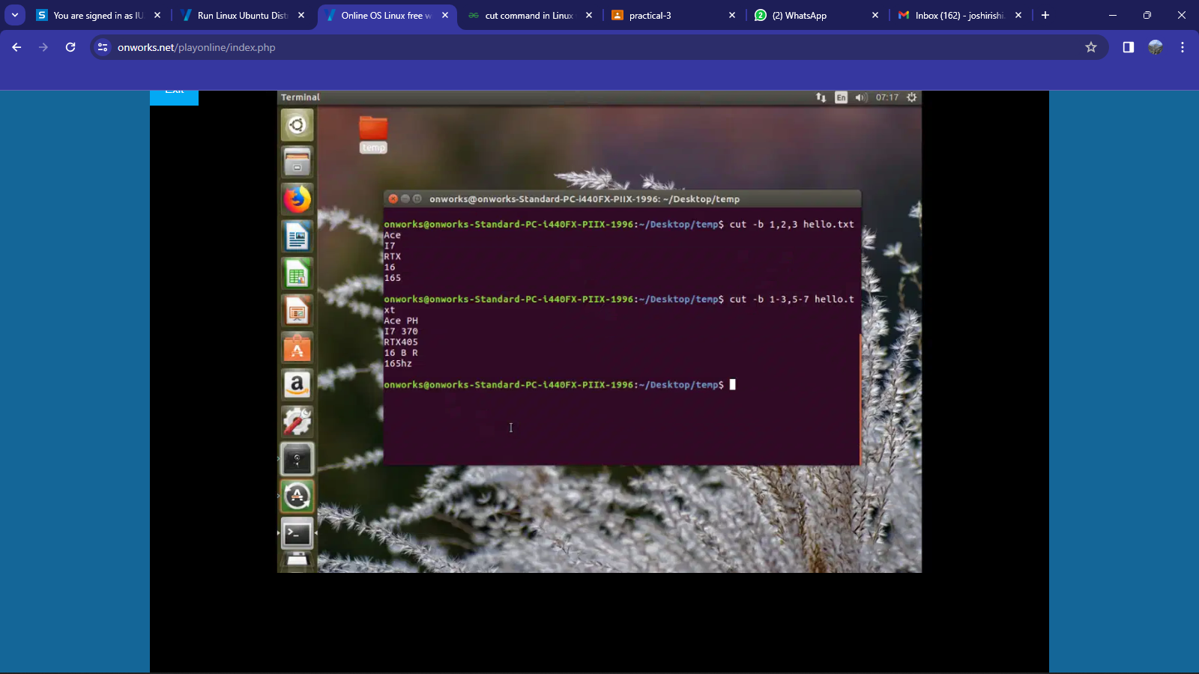Example:

1. **paste** - The "paste" command in Linux is used to merge lines from multiple files or standard input, displaying them side by side, separated by a specified delimiter.

**Syntax**:

     paste [OPTION]... [FILE]...

**Description:**

The "paste" command in Linux is a text-processing tool that horizontally merges lines from multiple files or standard input, aligning them side by side. It is commonly used for combining data from different sources or creating formatted output, with an option to specify a delimiter between the merged columns. "paste" is particularly useful for merging data sets or files with corresponding lines that need to be consolidated for analysis or presentation.

Use of Command:

·        -s or --serial: Merges lines from files vertically with a newline delimiter.

·        -d or --delimiter: Specifies a custom delimiter for merging.

|  |
| --- |
|  |
|  |  |

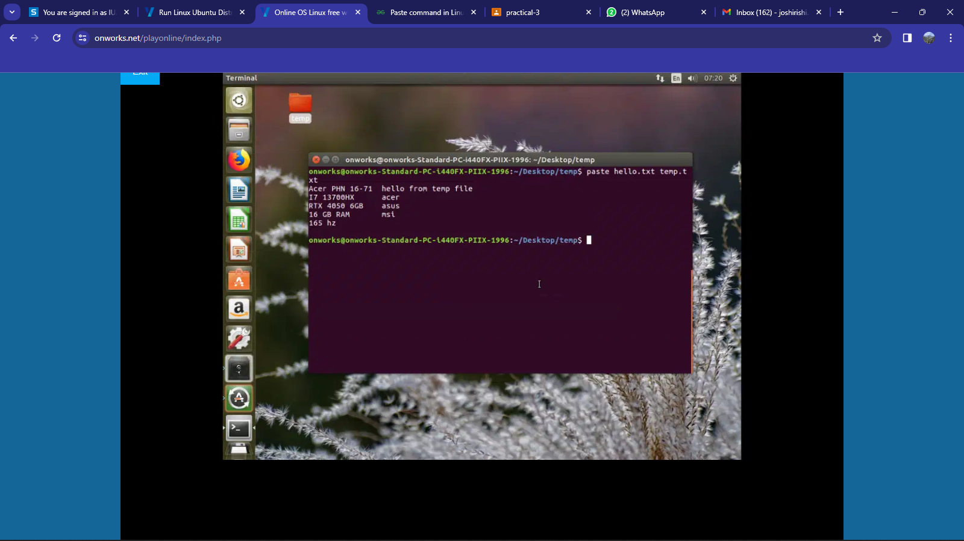Example:

1. **more** - The "more" command in Linux is used for viewing the content of text files one screen at a time, providing a paginated display that allows users to navigate through the text using keyboard commands.

**Syntax**:

     more [options] [file]

**Description:**

The `more` command in Linux is a terminal pager that allows users to view the contents of a text file one screen at a time. It provides a paginated display, allowing users to navigate through the file using keyboard commands. This command is particularly useful for viewing large files in a readable and manageable way, offering features like scrolling, searching, and jumping to specific sections.

Use of Command:

·        -n or --lines: Specifies the number of lines to display at a time.

* -d or --count: Shows the total number of lines in the file being viewed.
* -p or --no-preserve-screen: Does not clear the screen after exiting more.
* -c or --clear-screen: Clears the screen before displaying the file.

|  |
| --- |
|  |
|  |  |

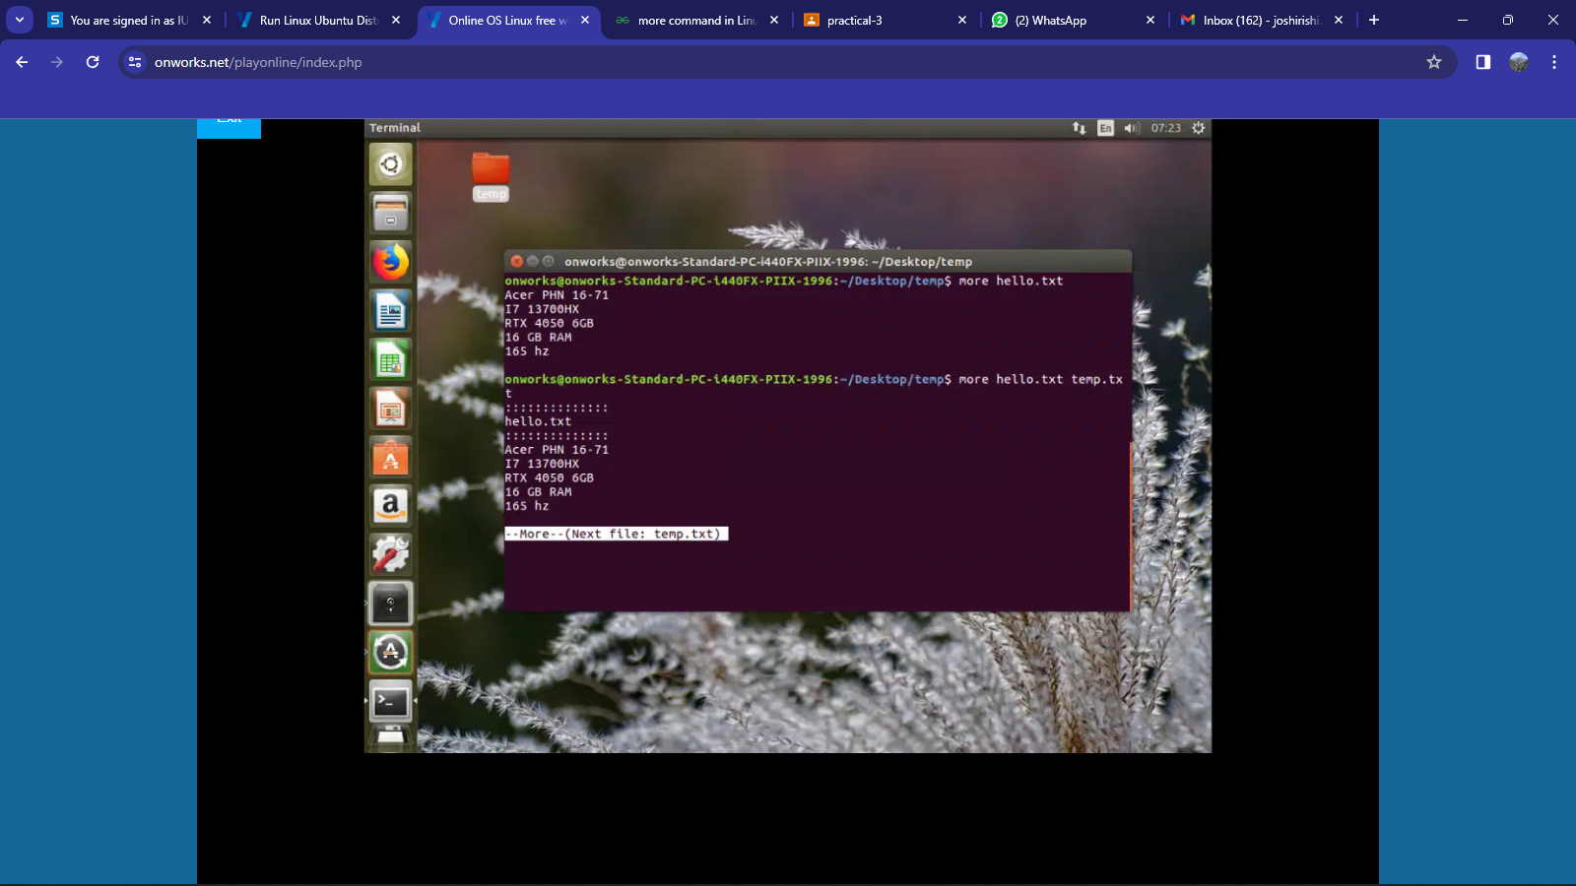Example:

1. **cmp** - The "cmp" command in Linux is used to compare two files byte by byte and display the first mismatch, providing information about the differing byte and line numbers.

**Syntax**:

     cmp [OPTION]... FILE1 [FILE2 [SKIP1 [SKIP2]]]

**Description:**

The "cmp" command in Linux is a utility that compares two files byte by byte, displaying the first differing bytes and their respective line numbers. It is commonly used to identify discrepancies between files and pinpoint the exact locations where differences occur. The command can be customized to skip a specified number of bytes at the beginning of each file for more targeted comparisons. The absence of any output indicates that the files are identical.

Use of Command:

·        -b or --print-bytes: Displays the differing bytes as well as their hexadecimal values.

* -i or --ignore-initial: Skips the first N bytes in both files during the comparison.
* -l or --verbose: Displays detailed information, including the byte and line numbers of the first differing byte.
* -s or --quiet: Suppresses normal output; only error messages are displayed.

|  |
| --- |
|  |
|  |  |

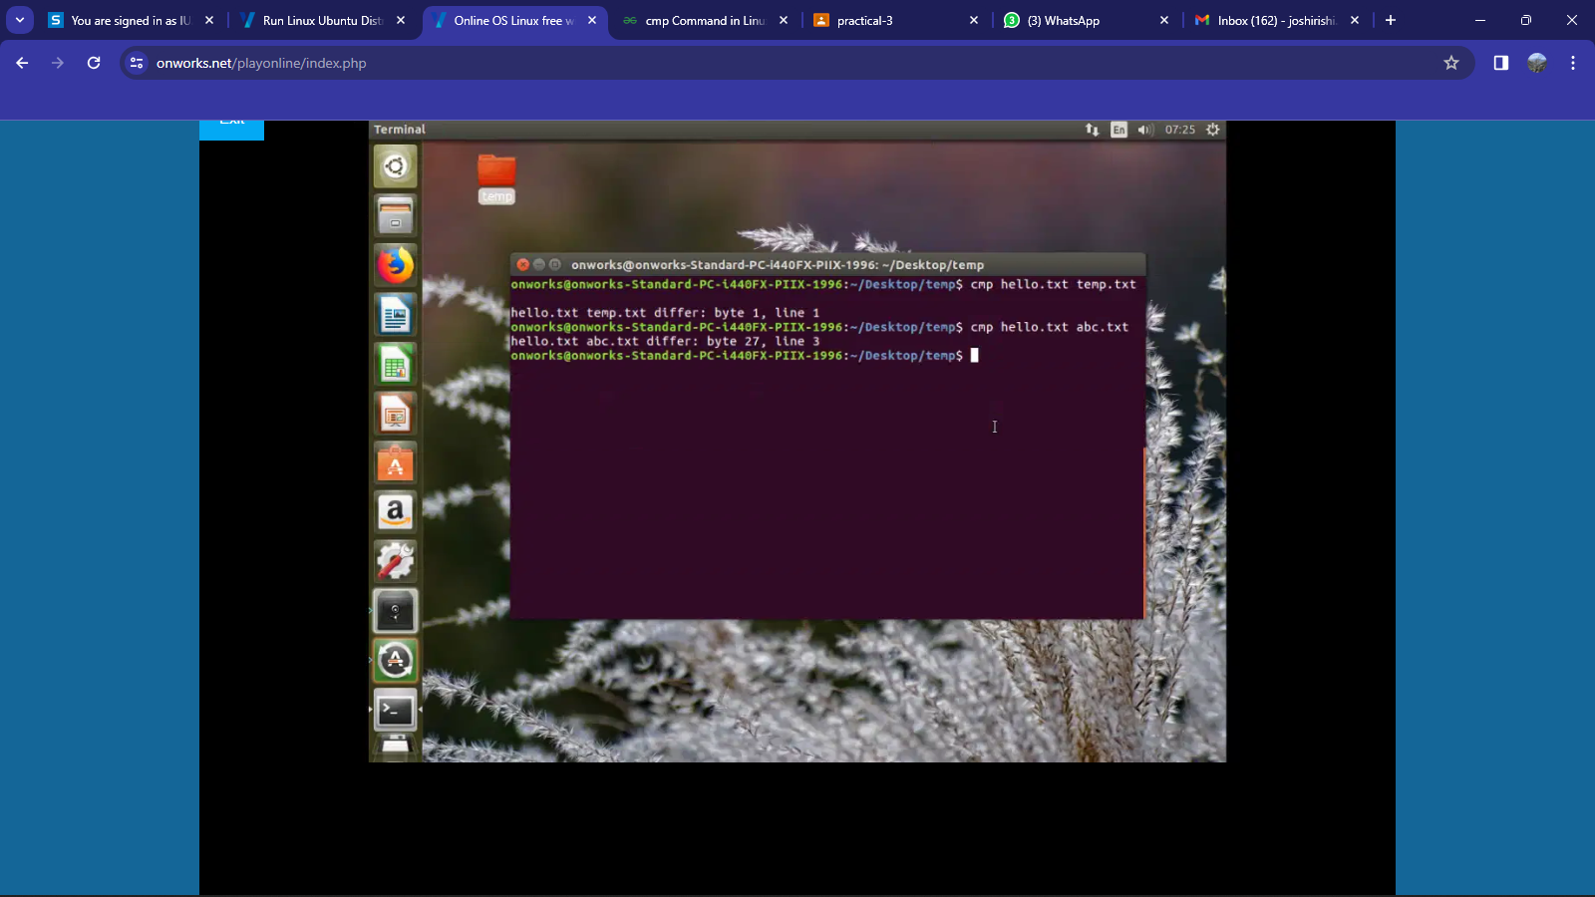Example:

1. **comm** - The "comm" command in Linux is used to compare two sorted files line by line, displaying lines unique to each file and common lines, offering a convenient way to identify differences and similarities between them.

**Syntax**:

     comm [OPTION]... FILE1 FILE2

**Description:**

The "comm" command in Linux is a utility that compares two sorted files line by line and produces three columns of output: lines unique to the first file (FILE1), lines unique to the second file (FILE2), and lines common to both files. It is particularly useful when working with sorted files, helping to identify differences and commonalities between the content of the two files. The command offers options for customizing the output and handling specific cases, providing flexibility in the comparison process.

Use of Command:

·        -1 or --suppress-column-1: Suppresses the first column, showing only lines unique to FILE2.

* -2 or --suppress-column-2: Suppresses the second column, showing only lines unique to FILE1.
* -3 or --suppress-column-3: Suppresses the third column, showing only lines
* -i or --ignore-case: Performs a case-insensitive comparison.

|  |
| --- |
|  |
|  |  |

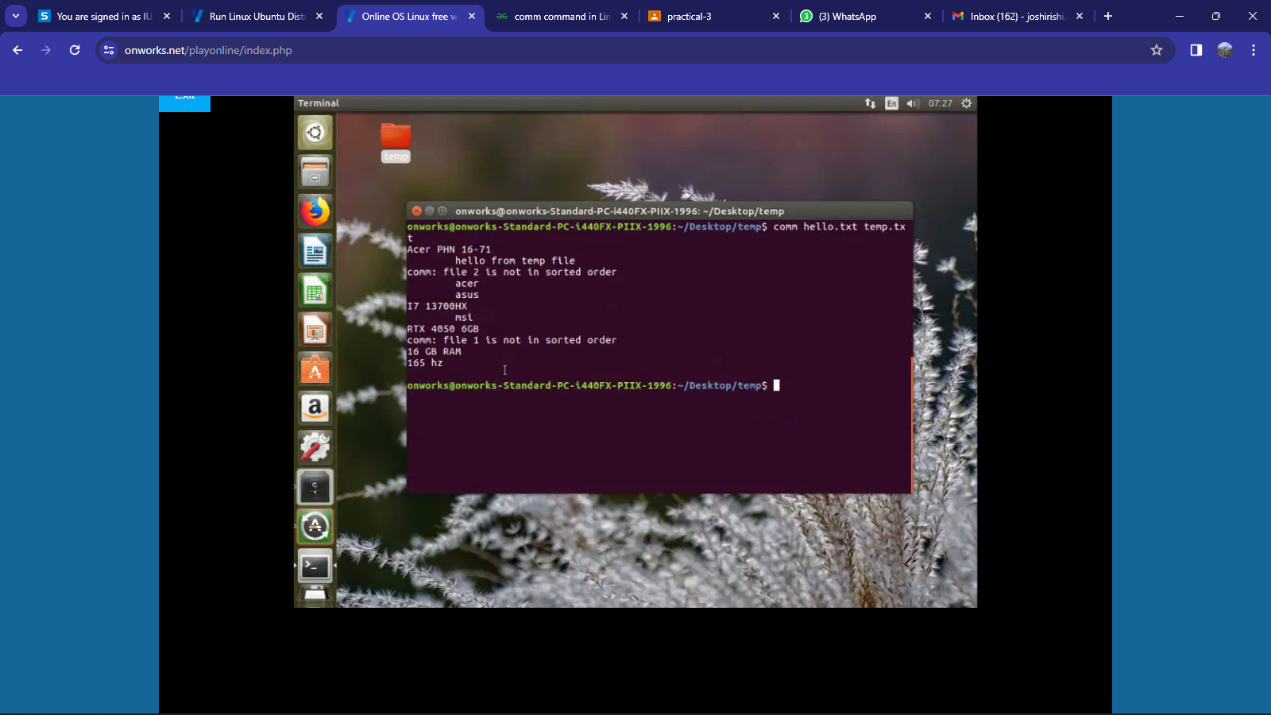Example:

1. **diff** - The "diff" command in Linux is used to compare and highlight differences between two text files, providing a line-by-line analysis of changes, additions, and deletions.

**Syntax**:

     diff [OPTION]... FILE1 FILE2

**Description:**

The "diff" command in Linux is a powerful utility used to compare the contents of two text files and highlight the differences between them. It provides a detailed line-by-line analysis, indicating additions, deletions, and modifications. "diff" is widely employed for code changes, file version tracking, and identifying discrepancies in various types of text-based files. The command offers numerous options for customization and can be used in conjunction with other tools for more complex comparison scenarios.

Use of Command:

·        -u or --unified: Produces a unified diff format, displaying changes in a compact and human-readable way.

* -i or --ignore-case: Performs a case-insensitive comparison.
* -r or --recursive: Compares files in subdirectories recursively.
* -c or --context: Displays lines of context around the differing lines for better readability.

|  |
| --- |
|  |
|  |  |

Example:

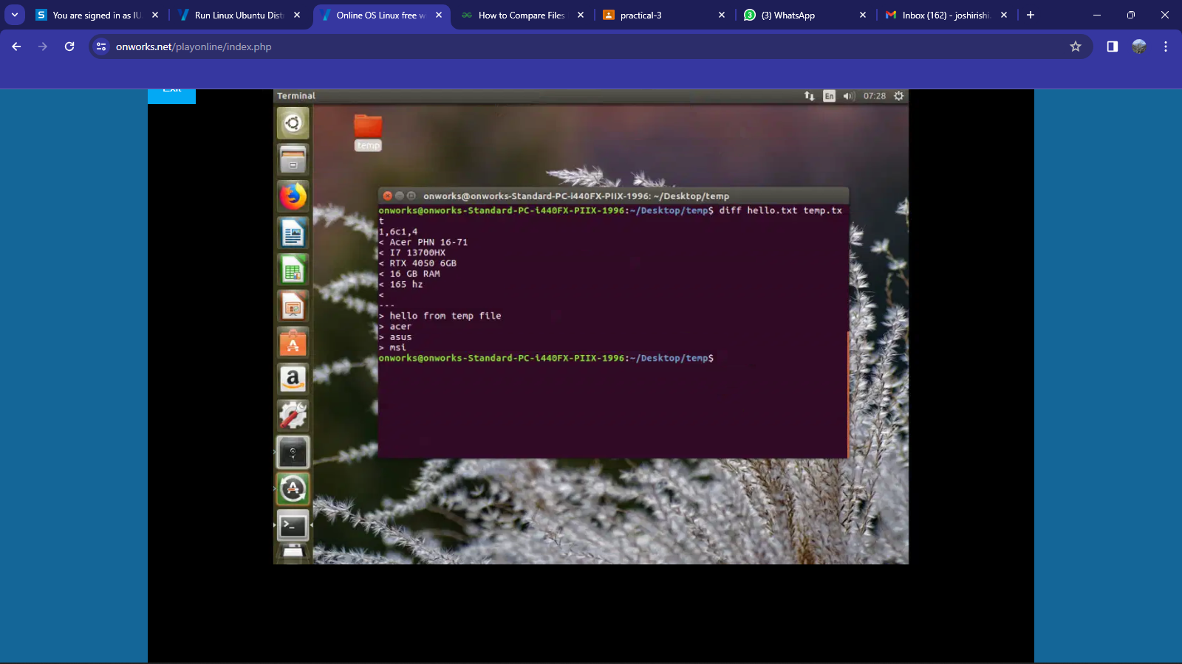

1. **chmod** - The "chmod" command in Linux is used to change the permissions of files and directories, allowing users to specify who can read, write, or execute the specified file or directory.

**Syntax**:

     chmod [OPTIONS] MODE[,MODE]... FILE...

**Description:**

The "chmod" command in Linux is a utility that allows users to change the permissions of files and directories. It enables users to control who can read, write, or execute a specified file or directory. Permissions are assigned based on three categories: user (owner), group, and others. Users can manipulate permissions using symbolic or numeric representations. Symbolic representations include symbols like "u" for user, "g" for group, "o" for others, and "+" for adding permissions, "-" for removing permissions, and "=" for setting permissions explicitly. Numeric representations involve three-digit codes, each digit representing the permission for user, group, and others, respectively. The "chmod" command provides flexibility in managing access control for files and directories in a Unix-like operating system.

Use of Command:

·        -R, --recursive: Apply the permission change recursively to all files and directories within the specified directory.

* -v, --verbose: Display a message for each file that is processed, indicating the permission change that was made.
* -c: Similar to -v, it displays messages only for files whose permissions are changed.
* -f, --silent, --quiet: Avoid displaying error messages.
* -h, --no-dereference: Change the permissions of symbolic links instead of the files they point to.

|  |
| --- |
|  |
|  |  |

Example:

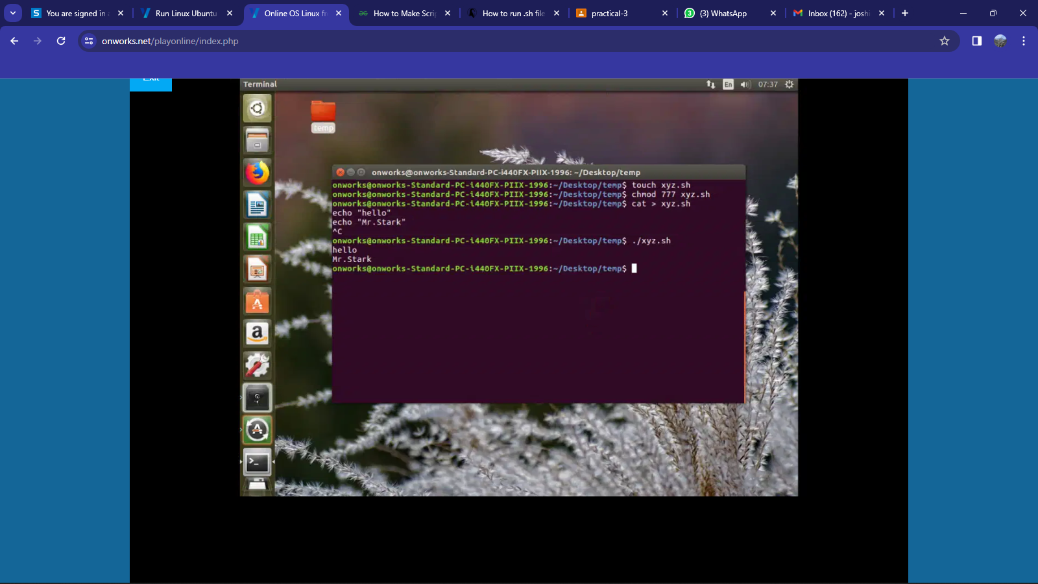

1. **chown** -  The "chown" command in Linux is used to change the owner and/or group of files and directories, allowing users to assign ownership to a specified user and group.

**Syntax**:

     chown [OPTIONS] [OWNER][:[GROUP]] FILE...

**Description:**

The "chown" command in Linux is a utility that enables users to change the owner and/or group ownership of files and directories. It is commonly used for managing file permissions and access control in a Unix-like operating system. Users can specify a new owner and an optional new group for the target files or directories. This command is crucial for system administrators and users with the appropriate privileges to regulate access to files and directories on a system. The "chown" command provides flexibility in managing ownership, contributing to security and proper organization of file systems.

Use of Command:

·        -R, --recursive: Apply ownership change recursively to all files and directories within the specified directory.

* -v, --verbose: Display a message for each file processed, indicating the ownership change made.
* -f, --silent, --quiet: Avoid displaying error messages during ownership change.
* -c: Similar to -v, it displays messages only for files whose ownership is changed.
* -h, --no-dereference: Affect symbolic links instead of referenced files.

|  |
| --- |
|  |
|  |  |

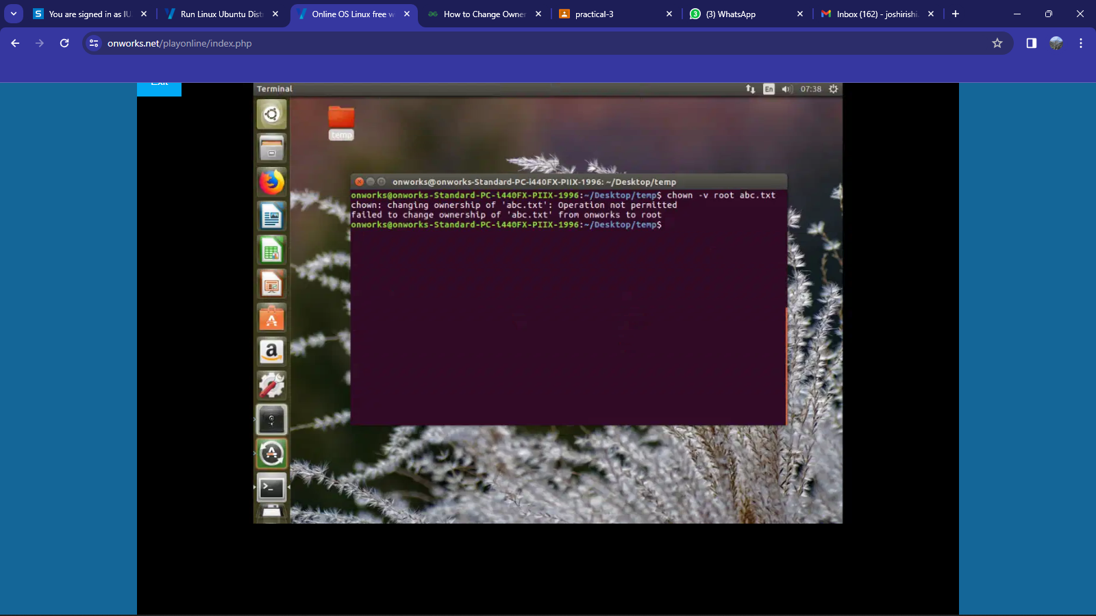  
Example:

1. **chgrp** - The "chgrp" command in Linux is used to change the group ownership of files and directories, allowing users to assign ownership to a specified group.

**Syntax**:

     chgrp [OPTIONS] GROUP FILE...

**Description:**

The "chgrp" command in Linux is a utility that facilitates changing the group ownership of files and directories. It allows users to assign ownership to a specified group, contributing to the management of file permissions and access control in a Unix-like operating system. Users can use the "chgrp" command to modify the group ownership of one or more files, ensuring proper organization and access to resources on the system. This command is particularly useful for system administrators and users with the appropriate privileges who need to regulate access to files and directories based on group ownership.

Use of Command:

·        -R, --recursive: Apply ownership change recursively to all files and directories within the specified directory.

* -v, --verbose: Display a message for each file processed, indicating the ownership change made.
* -f, --silent, --quiet: Avoid displaying error messages during ownership change.
* -c: Similar to -v, it displays messages only for files whose ownership is changed.

|  |
| --- |
|  |
|  |  |

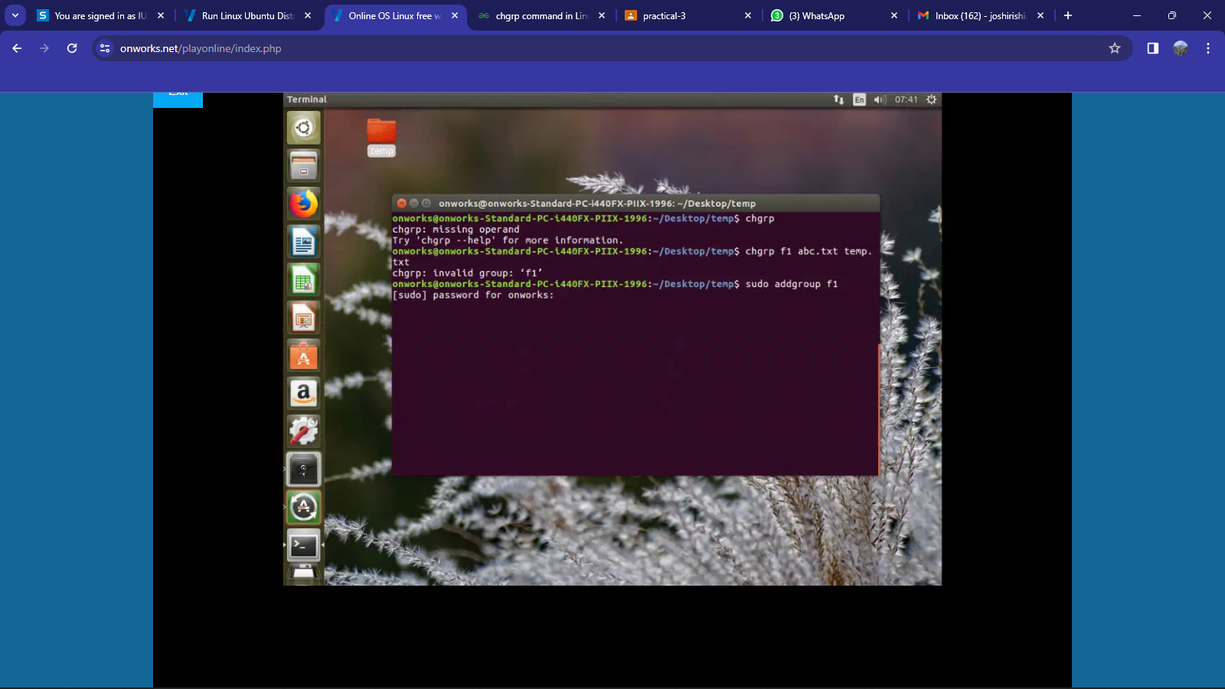Example:

1. **file** - The "file" command in Linux is used to determine and display the type of a file, providing information about its format, encoding, and content characteristics.

**Syntax**:

     file [OPTION]... [FILE]...

**Description:**

The "file" command in Linux is a utility that examines the content of files to determine their type, encoding, and other characteristics. It uses various methods, including magic numbers and patterns, to identify the file format. The output typically provides information such as file type, MIME type, and a brief description of the file. This command is valuable for users and system administrators to quickly ascertain the nature of a file, especially when dealing with diverse file formats in a Unix-like operating system.

Use of Command:

·        -b, –brief : This is used to display just file type in brief mode.

* * option : Command displays the all files’s file type.
* -c option: Cause a checking printout of the parsed form of the magic file. This option is usually used in conjunction with the -m flag to debug a new magic file before installing it.
* -f option: Read the names of the files to be examined from namefile (one per line) before the argument list. Either namefile or atleast one filename argument must be present; to test the standard input, use ‘-’ as a filename argument.
* -i option: To view mime type of file.
* -s option: For special files.
* -z option: Try to look inside compressed files.

|  |
| --- |
|  |
|  |  |

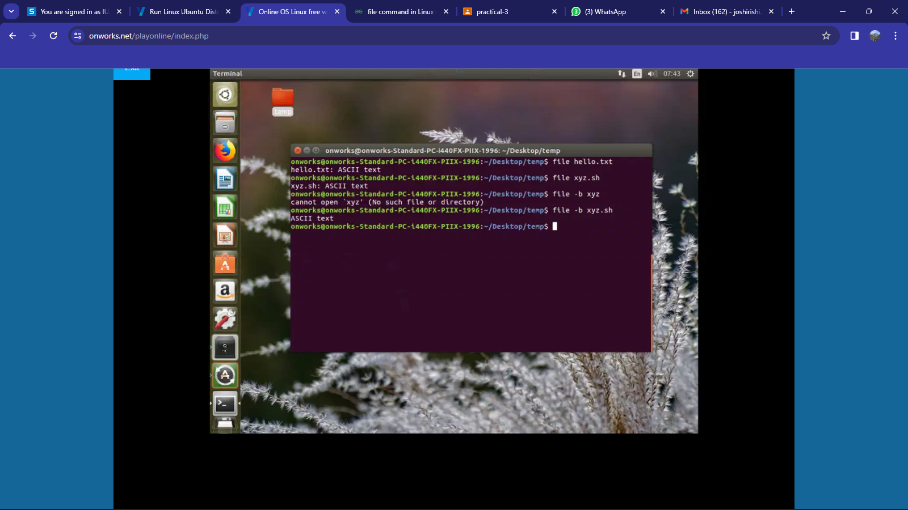  
Example:

1. **finger** - The "finger" command in Linux is employed to gather information about users on a system, providing details such as login name, real name, terminal, idle time, and login time.

**Syntax**:

     finger [OPTIONS] [USERNAME]...

**Description:**

The "finger" command is a utility that enables users to retrieve information about other users on a system. It displays details such as login name, real name, terminal, idle time, and login time. This command is useful for monitoring user activity and checking who is currently logged in.

Use of Command:

·        -l or --long: Provides a detailed long-format output, including additional information about each user.

·        -s or --short: Produces a shorter output, showing only essential information about each user.

·        -m or --mail: Shows information about the user's mailbox status, indicating whether there are unread messages.

* -q or --quick: Provides a quick summary, showing only the login names and terminal information of the specified users.
* -p or --phone: Displays users' phone numbers if available.

|  |
| --- |
|  |
|  |  |

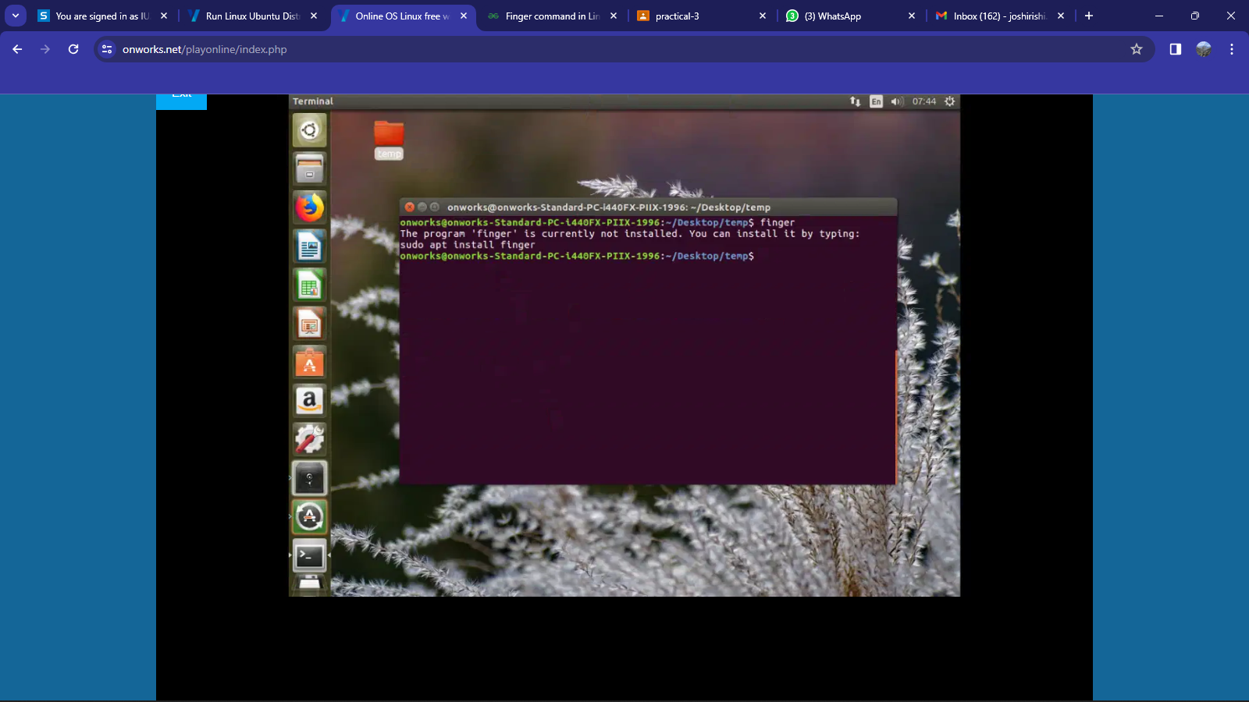Example:

1. **ps** - The "ps" command in Linux is used to provide information about currently running processes, offering insights into the system's resource utilization and process statuses.

**Syntax**:

     ps [OPTIONS]

**Description:**

The "ps" command is a versatile utility that provides a snapshot of the system's running processes. It offers details such as process IDs, states, resource utilization, and execution time. This command is crucial for monitoring system activity and diagnosing issues related to running processes.

Use of Command:

·        -e or --everyone: Displays information about every process on the system, including those owned by other users.

·        -f or --full: Provides a full-format output, displaying detailed information about each process.

·        -l or --long: Produces a long-format output, including additional information about processes.

* -u or --user USERNAME: Shows processes owned by a specific user.
* -o or --format FORMAT: Specifies a user-defined format for displaying information about processes.

Example:

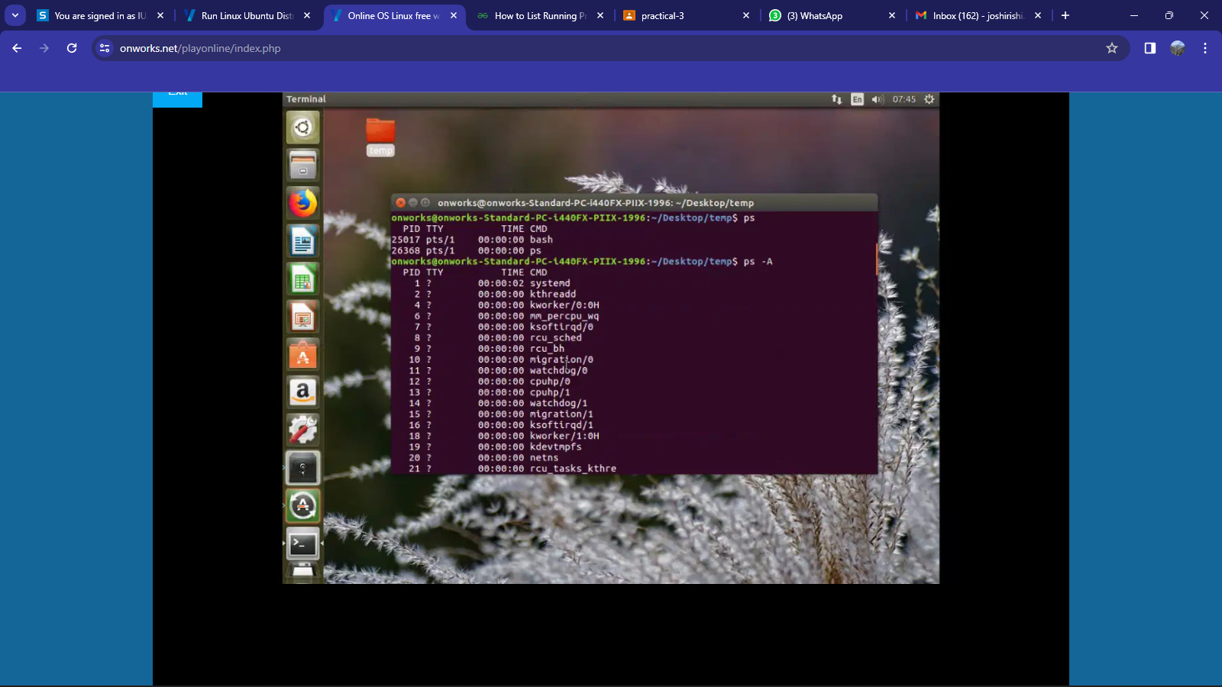

1. **kill** - The "kill" command in Linux is employed to terminate or send signals to processes, allowing users to control the execution of running programs.

**Syntax**:

     kill [OPTIONS] PID...

**Description:**

The "kill" command is a crucial tool for managing processes on a Linux system. It allows users to send signals to processes, facilitating actions such as terminating, stopping, or restarting them. This command is particularly useful for ending unresponsive or unwanted processes.

Use of Command:

·        -l or --list [SIGNAL]: Lists available signals or provides information about a specific signal.

·        -s or --signal SIGNAL: Specifies the signal to send. If not provided, the default signal is SIGTERM (15).

·        -9 or -SIGKILL: Forces the termination of a process by sending the SIGKILL signal.

* -l or --list [SIGNAL]: Lists available signals or provides information about a specific signal.
* -p or --pid PID: Specifies the process ID of the target process.
* -u or --user USERNAME: Terminates processes owned by a specific user.

|  |
| --- |
|  |
|  |  |

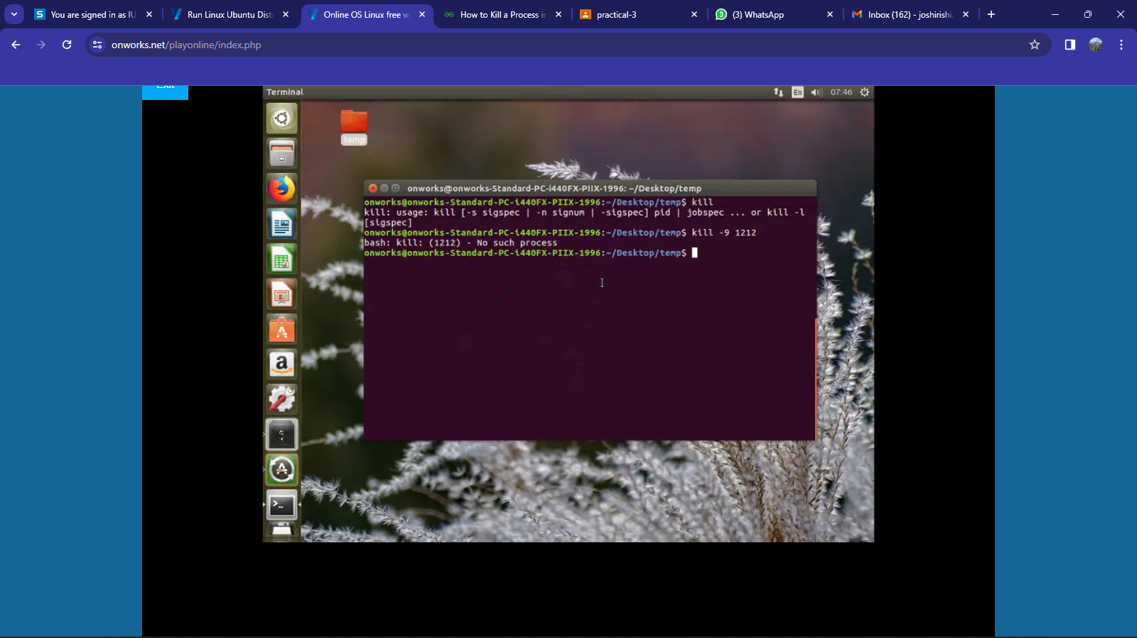  
Example:

1. **head** - The "head" command in Linux is used to display the beginning lines of a file or standard input, allowing users to preview the contents of a file quickly.

**Syntax**:

     head [OPTION]... [FILE]...

**Description:**

The "head" command is a utility for displaying the beginning lines of a file. By default, it shows the first 10 lines of each specified file. It is commonly used to preview the contents of large files or to examine the structure of a file.

Use of Command:

* -n or --lines=[-]K: Displays the first K lines. If K is negative, it displays all but the last K lines.
* -q or --quiet: Suppresses headers when multiple files are specified.
* -c or --bytes=[-]K: Displays the first K bytes. If K is negative, it displays all but the last K bytes.
* -v or --verbose: Always displays headers, even when processing a single file.

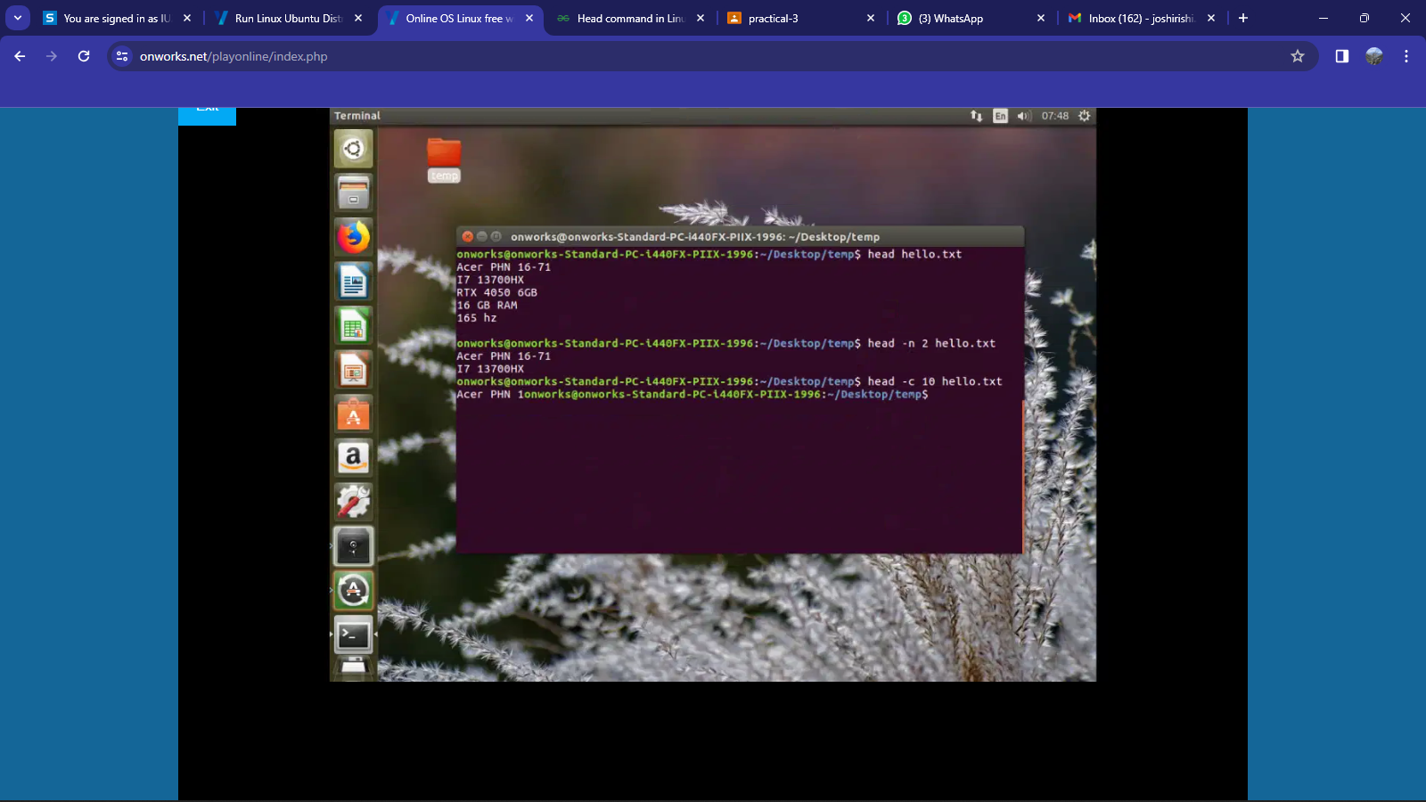Example

1. tail - The "tail" command in Linux is used to display the ending lines of a file or standard input, allowing users to view the last part of a file quickly.

**Syntax**:

     tail [OPTION]... [FILE]...

**Description:**

The "tail" command is a utility for displaying the ending lines of a file. By default, it shows the last 10 lines of each specified file. It is commonly used to monitor log files or to view the most recent entries in a file.

Use of Command:

* -n or --lines=[+]K: Displays the last K lines. If K is preceded by '+', it starts from the Kth line from the beginning of the file.
* - q or --quiet: Suppresses headers when multiple files are specified.
* -c or --bytes=[+]K: Displays the last K bytes. If K is preceded by '+', it starts from the Kth byte from the beginning of the file.
* -f or --follow[={name|descriptor}]: Outputs appended data as the file grows, continuously displaying new lines.

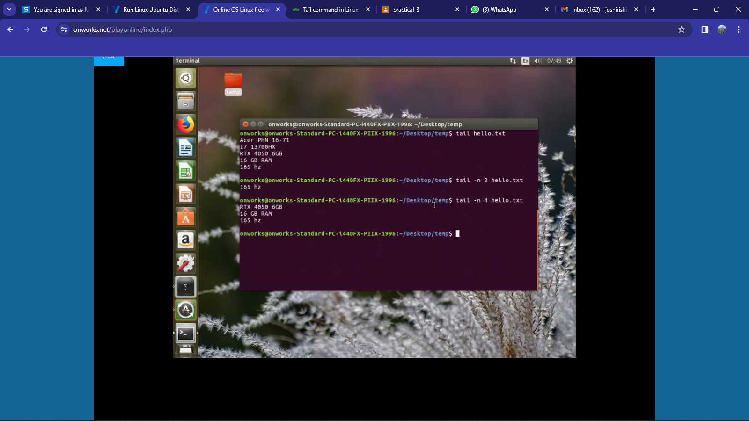  
Example:

1. **sort**- The "sort" command in Linux is used to sort lines of text files alphabetically or numerically, providing a way to organize and arrange data in ascending or descending order.

**Syntax**:

     sort [OPTION]... [FILE]...

**Description:**

The "sort" command is a utility for sorting lines of text files. By default, it sorts lines alphabetically in ascending order. It can also perform numeric sorting and handle different locales.

Use of Command:

* -r or --reverse: Reverses the result of comparisons, sorting in descending order.
* -n or --numeric-sort: Sorts numerically instead of alphabetically.
* -u or --unique: Suppresses duplicate lines, showing only unique lines.
* - k or --key=POS1[,POS2]: Sorts based on a key starting at position POS1 and optionally ending at POS2.

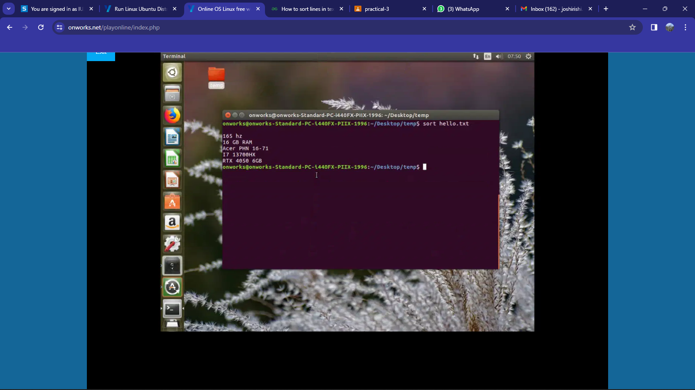  
Example:

1. **ln** - The "ln" command in Linux is used to create links between files, allowing multiple filenames to refer to the same data on disk.

**Syntax**:

     ln [OPTION]... TARGET [LINK_NAME]

**Description:**

The "ln" command creates links between files. By default, it creates hard links, which are direct references to the same data on disk. It can also create symbolic links (symlinks), which are indirect references to files.

Use of Command:

* -s or --symbolic: Creates symbolic links instead of hard links.
* -f or --force: Removes existing destination files before creating links.
* -t or --target-directory=DIRECTORY: Specifies the target directory where links will be created.
* -v or --verbose: Displays verbose output, showing the created links.

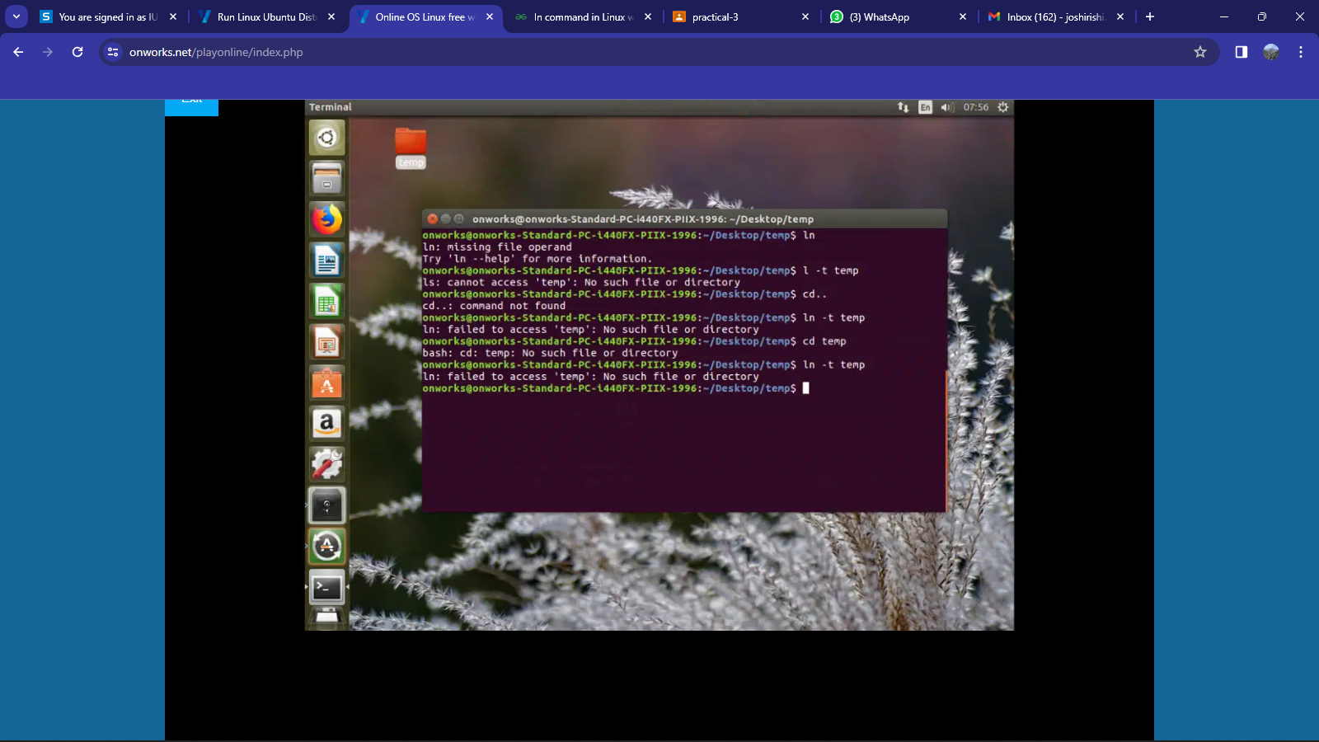Example:

1. **find**- The "find" command in Linux is used to search for files and directories within a specified directory hierarchy, providing a flexible and powerful tool for locating files based on various criteria.

**Syntax**:

     find [PATH] [OPTIONS] [EXPRESSION]

**Description:**

The "find" command is a versatile utility for searching files and directories recursively within a specified directory tree. It allows users to locate files based on various attributes such as name, type, size, permissions, and modification time.

Use of Command:

* -name PATTERN: Searches for files and directories with the specified name pattern.
* -type TYPE: Searches for files of the specified type (f for regular files, d for directories, l for symbolic links, etc.).
* -size [+|-]SIZE: Searches for files with the specified size (+ for larger than, - for smaller than, and no sign for exactly).
* -exec COMMAND {} +: Executes the specified command on the found files.

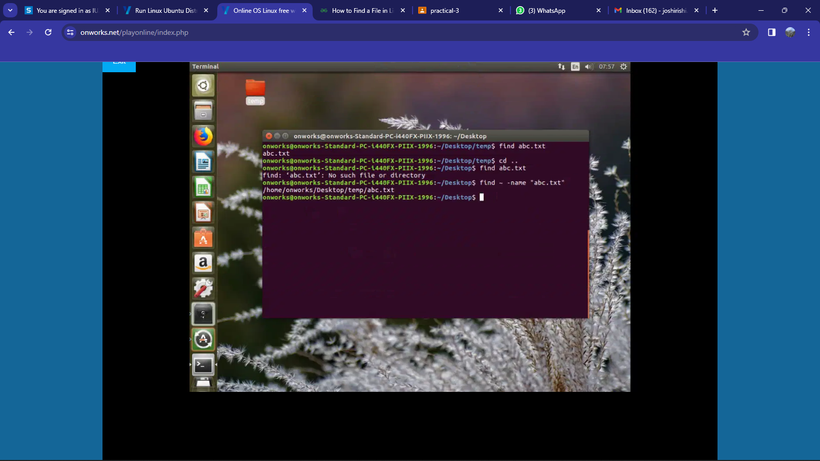  
Example:

1. **uniq** - The "uniq" command in Linux is used to filter adjacent matching lines from input, allowing users to identify or remove duplicate lines from sorted data.

**Syntax**:

     uniq [OPTION]... [INPUT [OUTPUT]]

**Description:**

The "uniq" command is a utility for filtering adjacent matching lines from input. It is commonly used to identify or remove duplicate lines from sorted data, making it useful for data preprocessing and analysis.

Use of Command:

* -c or --count: Prefixes lines with the count of occurrences.
* -d or --repeated: Displays only duplicate lines.
* -u or --unique: Displays only unique lines (removes duplicates).

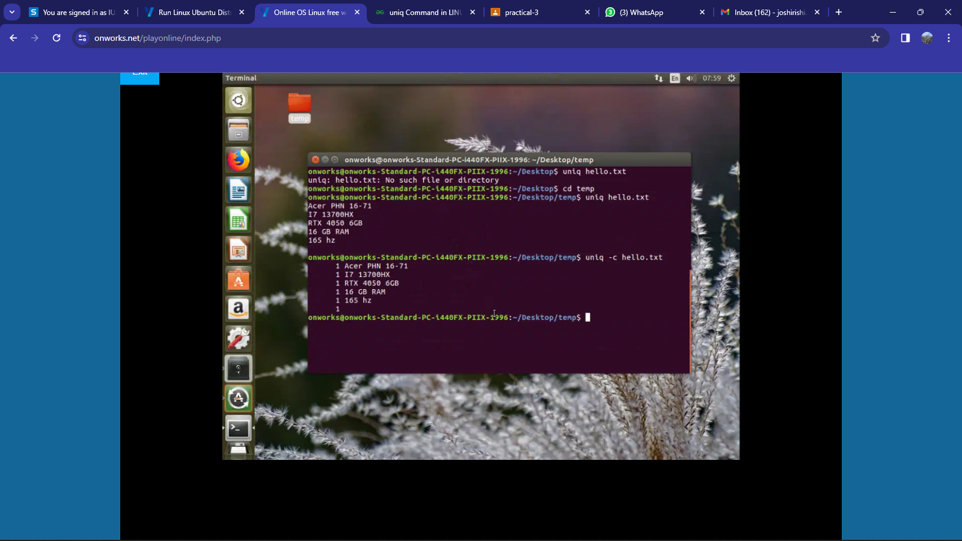  
Example:

1. **tr** - The "tr" command in Linux is used for translating or deleting characters, providing a versatile tool for text manipulation and transformation.

**Syntax**:

     tr [OPTIONS] SET1 [SET2]

**Description:**

The "tr" command is a powerful text-processing utility that facilitates character translation and deletion. It can be used to replace or remove specified characters from input data streams. This command is particularly useful for tasks involving character manipulation in text files or streams.

Use of Command:

* -d or --delete: Deletes characters in SET1 from the input.
* -c or --complement: Replaces characters not specified in SET1.
* -s or --squeeze-repeats: Replaces each sequence of repeated characters with a single occurrence.
* -t or --truncate-set1: First truncate SET1 to length of SET2 before processing.
* -u or --uppercase: Converts lowercase characters in SET1 to uppercase.

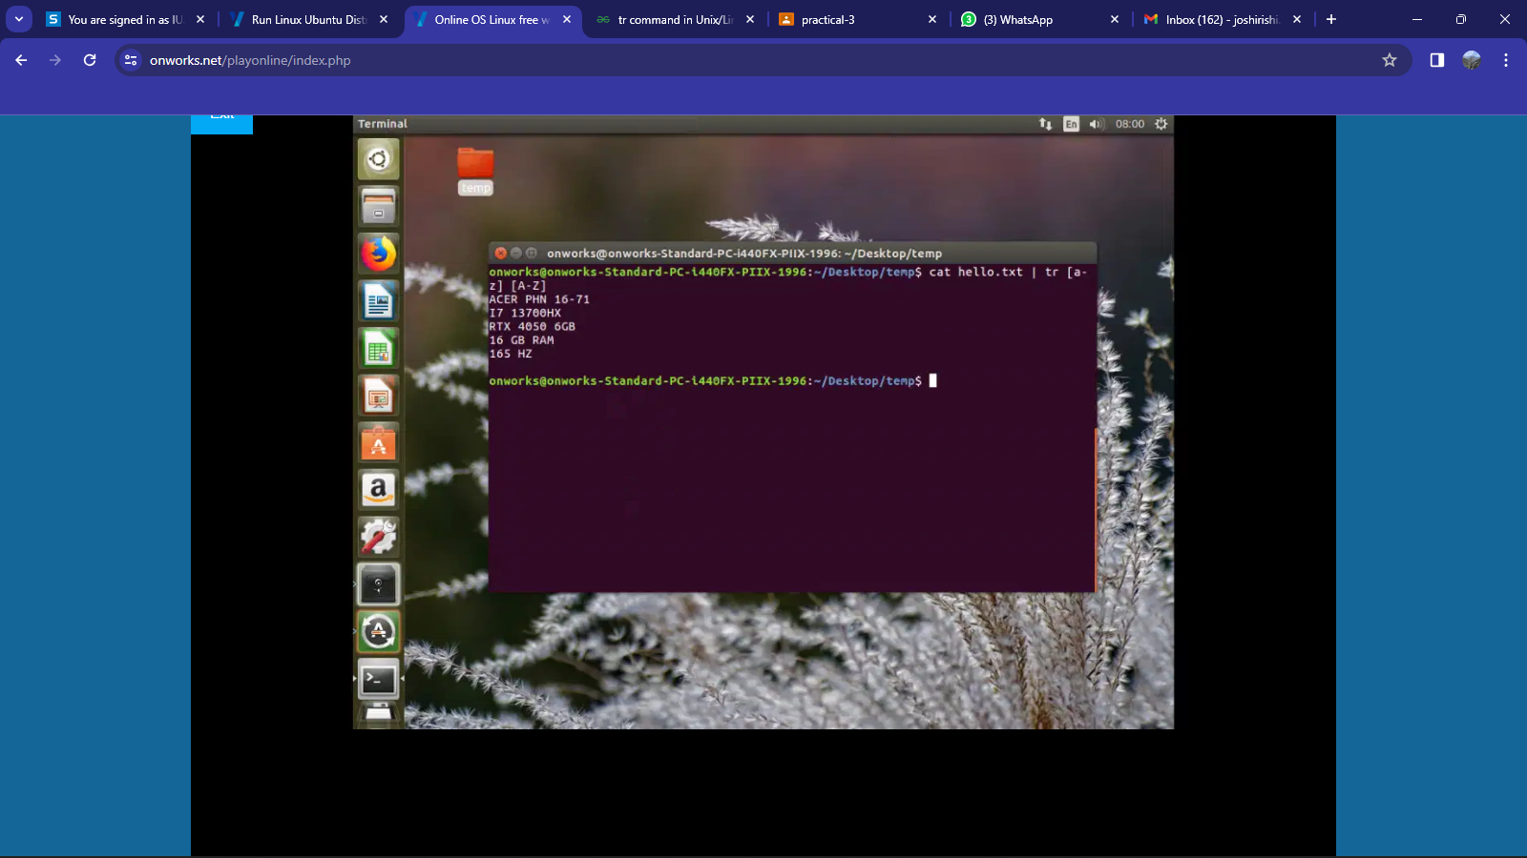  
Example:

1. **history** - The "history" command in Linux is used to display a list of previously executed commands, providing a convenient way to view and recall command-line history.

**Syntax**:

     history [OPTIONS]

**Description:**

The "history" command is a valuable utility for accessing the command-line history of a user. It displays a list of previously executed commands along with their corresponding line numbers. This command is useful for reviewing and reusing past commands, improving efficiency in the command-line interface.

Use of Command:

* -c or --clear: Clears the command history.
* -d offset or --delete offset: Deletes the command at the specified offset in the history.
* -a or --append: Appends the command to the history file immediately.
* -n or --nonincremental: Read all history lines, not just the new lines.
* -r or --read-only: Displays the history list without modifying the history file.
* -w or --write: Writes the current history to the history file.

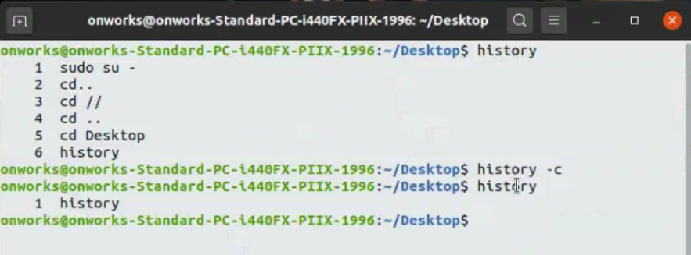  
Example:

1. **grep** - The "grep" command in Linux is used to search for patterns or specific text within files or command output, providing a powerful tool for text processing and filtering.

**Syntax**:

     grep [OPTIONS] PATTERN [FILE...]

**Description:**

The "grep" command is a fundamental text-processing utility that searches for patterns within files or input streams. It allows users to filter and extract lines containing specific text or match regular expressions. This command is essential for text searching and pattern matching in Linux.

Use of Command:

* -i or --ignore-case: Performs a case-insensitive search.
* -n or --line-number: Displays line numbers along with matching lines.
* -r or -R or --recursive: Searches recursively in directories.
* -v or --invert-match: Displays non-matching lines.
* -o or --only-matching: Displays only the matched part of the lines.

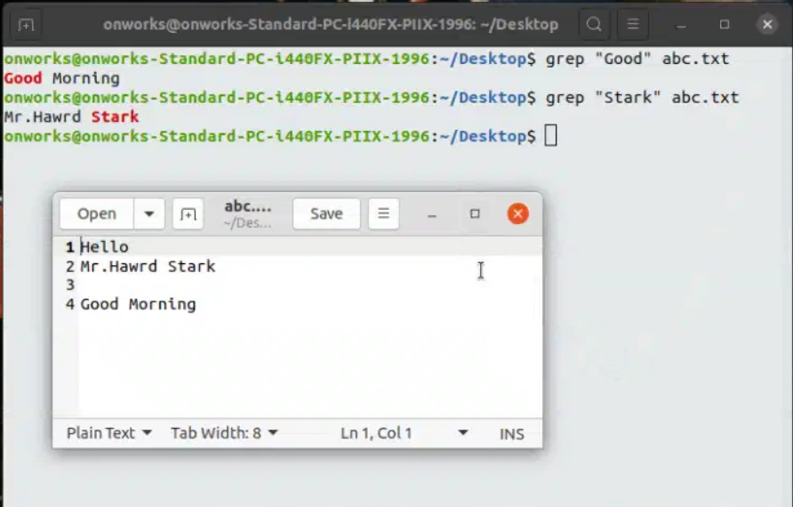Example:

1. wc - The "wc" command in Linux is used to count the number of lines, words, and characters in a file or standard input, providing essential information about the size and content of text.

**Syntax**:

     wc [OPTIONS] [FILE...]

**Description:**

The "wc" command is a simple yet powerful utility for displaying line, word, and character counts in files or input streams. It provides valuable information about the size and structure of text data. This command is frequently used for text analysis and reporting in Linux.

Use of Command:

* - l or --lines: Displays the number of lines.
* -w or --words: Displays the number of words.
* -c or --bytes: Displays the number of bytes (characters).
* -m or --chars: Displays the number of characters.
* -L or --max-line-length: Displays the length of the longest line.

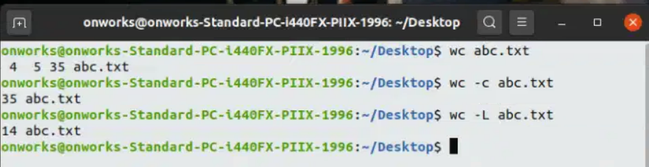  
Example:

1. **| (pipeline)** -  The pipe command in Linux is used to connect the output of one command to the input of another, allowing for the creation of command pipelines.

**Syntax**:

     command1 | command2

**Description:**

The pipe (|) command enables the chaining of multiple commands together, where the output of one command serves as the input to the next command in the pipeline. This facilitates the processing of data through a sequence of operations, allowing for complex tasks to be performed efficiently.

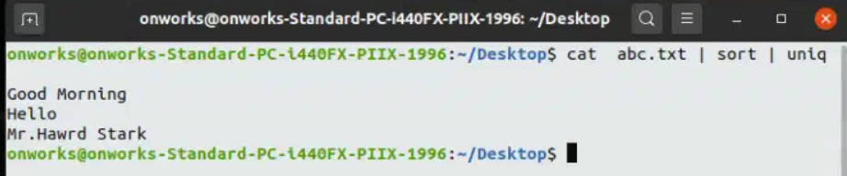  
Example:

1. wall - The "wall" command in Linux is used to broadcast a message to all users currently logged into the system, providing a means for system administrators or users to communicate important information.

**Syntax**:

     wall [OPTIONS] [MESSAGE]

**Description:**

The "wall" command is a utility for sending a message to all users on the system, typically used by administrators to convey important announcements or warnings. It is a tool for real-time communication that allows system-wide dissemination of information.

Use of Command:

* -n or -nobeep: Prevents the terminal beep when broadcasting the message.
* -t or --time TIME: Specifies a time delay before the message is broadcasted.
* -h or --help: Displays the help message for the "wall" command.

Example:

